Sharps and Flats Note Identification

Identify each note. If there is a sharp use the # symbol. If there is a flat use a lowercase b. Example: F# for F Sharp and Bb for B Flat. Place each answer under each note. Pay attention to what clef you are working on! First line is treble clef and second line is bass clef.

F# Fb Gb A
Cb D A
Gb Fb F# A
Gb Fb D

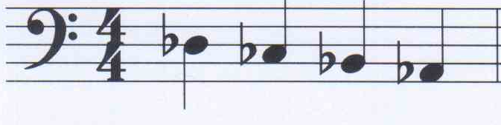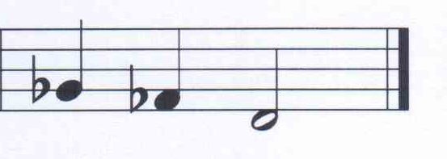
Db Cb Bb Ab
Bb Ab A

